BCT Assignment 1
Creating a Metamask Wallet
Neeti Kurulkar

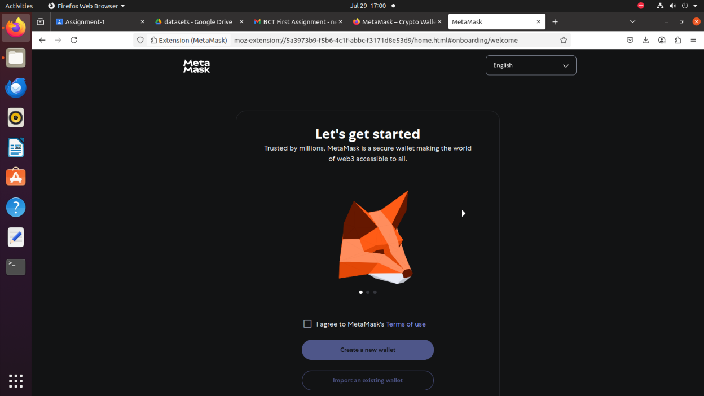
Fig 1: Add Metamask Extension for Firefox
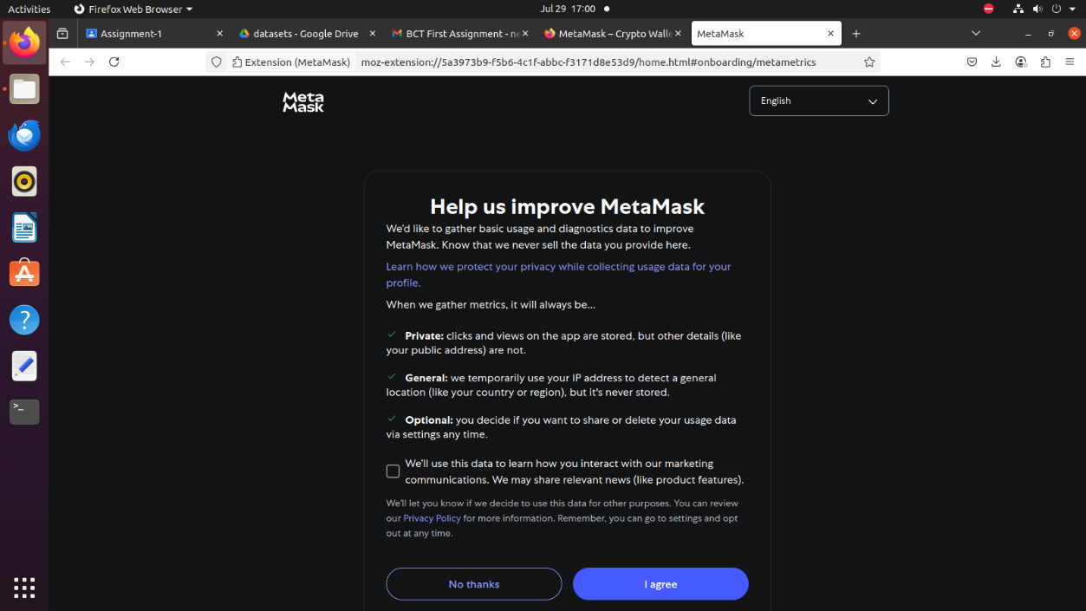
Fig 2: Agree to Terms and Conditions

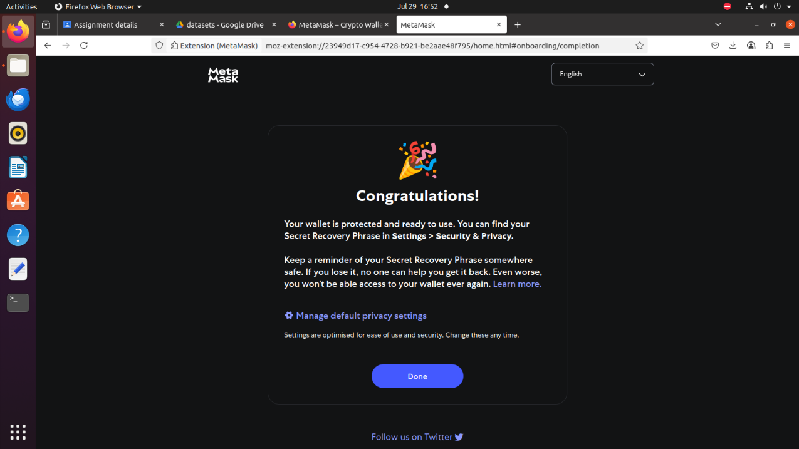
Fig 3: Metamask successfully installed

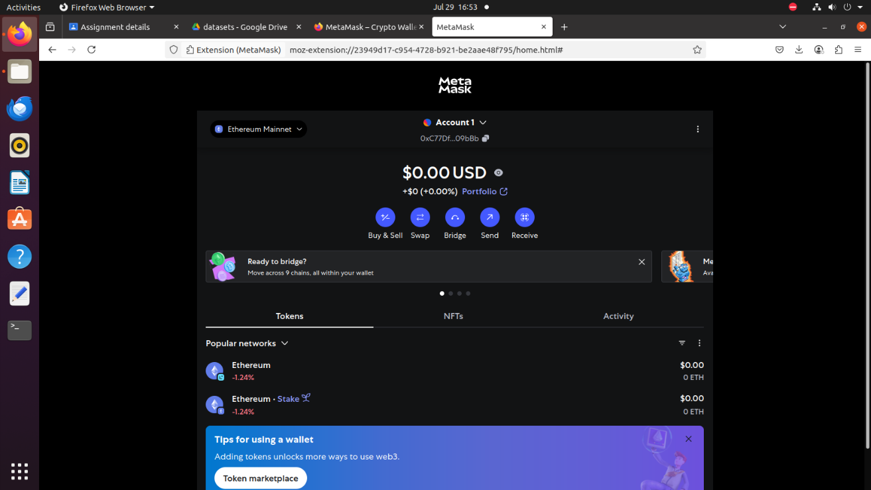
Fig 4: View Wallet

